AI reasoning interface description
This interface is suitable for inference process based on TensorRT object segmentation model. The following is the environment configuration and function description of AI inference interface.
- C++ Environment Configuration (TensorRT)
Tensorrt8 corresponds to cuda11.3;
Included directories: (TensorRT, opencv, CUDA)
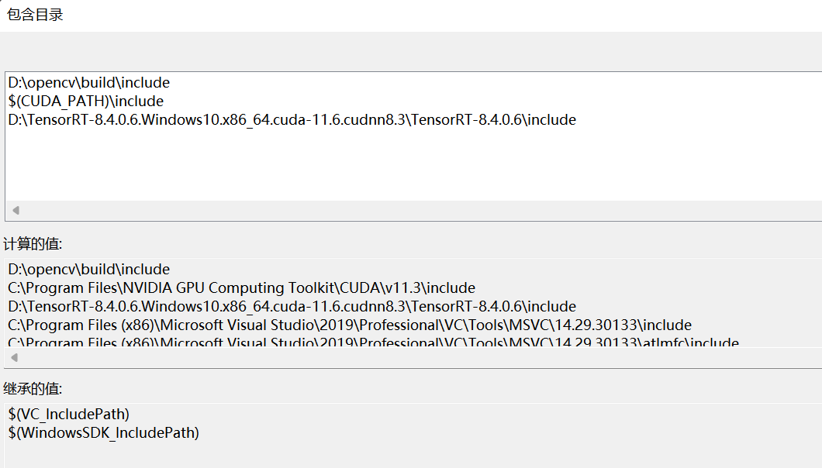

Library directory：（TensorRT、opencv、CUDA）
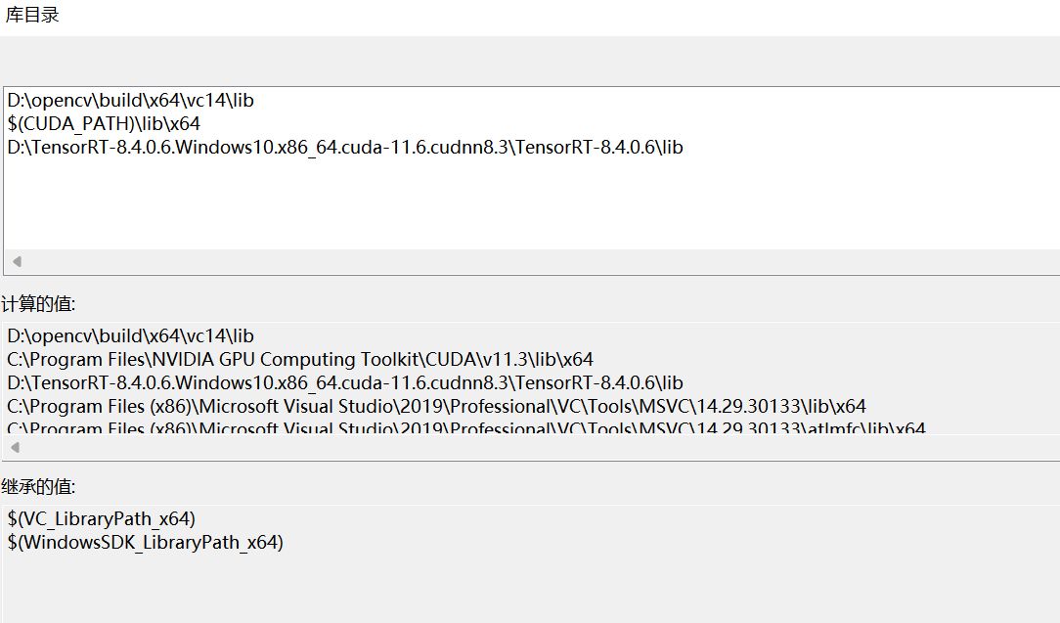

Linker - Attached dependencies：
opencv_world342d.lib（The library is changed according to the opencv version）
cublas.lib
cuda.lib
cudadevrt.lib
cudart.lib
cudart_static.lib
cufft.lib
cufftw.lib
curand.lib
cusolver.lib
cusparse.lib
nvinfer.lib
nvinfer_plugin.lib
nvonnxparser.lib
nvparsers.lib

- interface function description
- AIInit
Function introduction: AI model loading and GPU memory initialization
Parameter: engineFilePath is the path of the AI model
engineMode is AI detection mode (default object segmentation "seg")
Returns: A pointer to the parameter structure
typedef struct
{
std::string engine_mode;
float* data;
float* prob;
float* prob1;
int output_size;
int output1_size;
IRuntime* runtime;
ICudaEngine* engine;
IExecutionContext* context;
cudaStream_t stream;
int _segWidth, _segHeight, _segChannels, Num_box;
int inputIndex;
int outputIndex;
}Yolov5TRTContext;

void* AIInit(uchar* engineFilePath， std::string engineMode);

2.AIDetect
Function introduction: AI model inference result feedback
Parameter: h is a pointer to the initialized parameter structure
inputImagePath is the image to be detected
outputResult is the output structure pointer
Return: outputResult
struct OutputSeg {
std::string classname; //Result category
float confidence; //Result confidence
cv::Rect box; //Rectangular box
cv::Mat boxMask; //Rectangular box inside mask
};

void AIDetect(void* h, char* inputImagePath, void* outputResult)

3.Freecuda
AI model memory release
Parameter: h is a pointer to the initialized parameter structure
Return: none
void Freecuda(void* h);

